CHAPTER 1
INTRODUCTION
  - Introduction
Sports analytics has become an important part of modern sports management and performance improvement. With the advancement of technologies such as Artificial Intelligence (AI), Machine Learning, and data analytics, teams and athletes are now able to analyze large amounts of performance data to improve their strategies and decision-making processes. AI-based sports analytics systems help coaches and analysts evaluate player performance, predict injury risks, and develop better training methods.
At the same time, sports fans have also become more engaged through digital platforms that provide live updates, match statistics, and interactive features. However, most existing platforms either focus on professional analytics used by teams or provide entertainment-based features for fans. Very few systems attempt to combine both professional-level insights and fan interaction in a single ecosystem.
This project introduces Kinetix, an AI-powered sports ecosystem designed to bridge the gap between professional sports analytics and fan engagement. The system includes two main platforms: a Professional Analytics Portal for athletes and analysts, and a Public Simulation Hub where fans can participate in real-time prediction games. By integrating advanced analytics with interactive features, the platform aims to enhance both professional decision-making and fan participation.

  - Evolution of AI-Based Sports Analytics Systems
The use of data analysis in sports began with basic statistical tracking such as scores, averages, and player records. Over time, the availability of large datasets and advanced computing technologies allowed teams to perform deeper performance analysis. Early sports analytics systems mainly focused on historical performance data to evaluate players and team strategies.
With the introduction of Artificial Intelligence and Machine Learning, sports analytics has evolved significantly. Modern AI-based systems can analyze biometric data, track player movement, predict injury risks, and simulate different tactical scenarios. Technologies such as wearable sensors, computer vision, and predictive algorithms are now widely used in professional sports environments.
Despite these advancements, most analytics tools remain restricted to professional teams and organizations. Meanwhile, fan engagement platforms often rely on simple prediction games or fantasy leagues without integrating real analytical insights. This evolution highlights the need for a system that connects professional analytics with fan-driven insights, which forms the foundation of the Kinetix platform.

  - Aim
The main aim of this project is to develop an AI-powered sports analytics ecosystem that integrates professional performance analysis with interactive fan engagement. The system aims to provide advanced analytical tools for sports professionals while also creating an engaging platform where fans can participate in sports prediction and simulation activities.

  - Objective
The Kinetix system is designed with several ambitious objectives that blend professional sports analytics with fan engagement. Its primary aim is to build a Professional Analytics Portal tailored for athletes, coaches, and analysts, enabling them to evaluate player performance through advanced data-driven techniques. Beyond performance tracking, the system integrates AI-assisted tactical insights and injury risk prediction, offering actionable intelligence to improve decision-making and safeguard athlete health. On the public side, Kinetix introduces a Simulation Hub where fans can actively participate in real-time predictions, supported by a Predict-the-Play gamified model that rewards accurate forecasts with points. Finally, the system explores the innovative concept of crowd intelligence, analyzing large volumes of fan predictions to uncover collective insights that could influence tactical strategies and enrich the overall sporting experience.

  - Scope
The scope of the Kinetix project focuses on building a digital ecosystem that connects professional sports analytics with fan interaction.The system will provide tools for analyzing player performance, tracking match events, and generating predictive insights. It will also allow fans to engage with live matches through interactive prediction features.In the future, the platform can be expanded to include multiple sports, advanced AI models, real-time data integration, and partnerships with sports organizations.

1.6 Significance and Impact
The Kinetix platform has the potential to significantly impact both professional sports analysis and fan engagement. By combining advanced analytics with interactive fan participation, the system creates a more comprehensive sports intelligence ecosystem.
For professional teams, the platform provides valuable insights that can support better training strategies, performance evaluation, and decision-making. For fans, it offers a more engaging and educational experience by allowing them to actively participate in predicting match events.
Furthermore, analyzing large volumes of fan predictions can generate crowd intelligence insights, which may reveal patterns in public perception of team strategies and player roles. This integration of professional analytics and fan-driven insights represents a new approach to sports data analysis and engagement.

1.7 Problem Motivation
The motivation behind developing the Kinetix platform comes from the limitations observed in existing sports analytics systems. Currently, most platforms focus either on professional analytics or on fan engagement, but very few systems combine both aspects in a single platform. Additionally, existing systems mainly provide pre-match or post-match analysis and lack real-time insights during live matches.
There is also limited interaction available for general users, as most analytics tools are designed only for experts such as coaches and analysts. This creates a gap between professional sports analysis and public understanding of the game.

Chapter 2
Literature Review
The literature review examines research on sports analytics, artificial intelligence, and machine learning techniques for analysing player performance and match outcomes. Over the past decade, the sports industry has increasingly adopted data-driven technologies to enhance training, evaluate athletes, and support tactical decisions.
Researchers have explored approaches such as machine learning algorithms, wearable sensors, computer vision, and predictive models to analyze sports data. These technologies enable teams to monitor fitness, detect injury risks, and assess match statistics more effectively. Modern analytics platforms also process large volumes of data in real time, allowing analysts to extract meaningful insights from performance metrics and match events.
However, most studies focus on professional sports systems used by coaches and organizations. Limited research addresses integrating analytics with fan engagement platforms or crowd-based predictions. Reviewing existing literature is therefore essential to understand current methods, highlight limitations, and identify how the proposed Kinetix platform can advance this domain.

2.1 Summary of Research Paper
Various research papers have investigated the use of artificial intelligence, machine learning, and data analytics in sports performance analysis. These studies highlight the importance of using data-driven approaches to improve decision-making in sports.
Several researchers have proposed systems that use machine learning algorithms to analyze historical match data and predict player performance. These models evaluate factors such as player statistics, match conditions, and performance trends to generate predictions about future outcomes. Other studies have explored the use of wearable sensor technologies to monitor athlete movements and collect biometric data such as heart rate, speed, and physical exertion. This information helps in detecting injury risks and improving training programs.
Some research has also focused on computer vision and deep learning techniques for analyzing player movements and match events through video data. These systems can automatically detect important actions during matches and provide valuable insights for performance analysis.
Additionally, several studies discuss the development of real-time sports analytics platforms capable of processing large volumes of sports data and generating tactical insights for teams and analysts. While these research works contribute significantly to the field of sports analytics, most of them focus mainly on professional sports environments and do not address the integration of fan participation in sports analysis.
Table 2.1 Summary of Literature Paper
Author(s) | Year | Title of Paper | Method / Technology Used | Key Contribution | Limitation
Mandot & Chawla | 2013 | AI and Machine Learning Applications in Sports Performance Analysis | Artificial Intelligence, Machine Learning | Demonstrates use of AI models for analyzing player performance and strategy | Limited real-time analytics and small datasets
Hassan et al. | 2024 | Wearable Sensor Data Analytics for Athlete Performance and Injury Prevention | Wearable Sensors, Data Analytics | Uses wearable devices to track athlete health and performance | Dependence on sensor accuracy and device availability
Agrawal & Kandhway | 2024 | Predictive Analytics in Sports: Injury Risk Assessment and Performance Optimization | Predictive Analytics, Machine Learning | Predicts injuries and performance outcomes using historical data | Requires large and high-quality datasets
Thander | 2023 | Biomechanics of the Bowling Delivery in Cricket: A Critical Analysis | Biomechanics Analysis | Studies bowling mechanics to improve performance and reduce injury | Focuses only on bowling biomechanics
Obi et al. | 2024 | Data Science in Sports Analytics: A Review of Performance Optimization and Fan Engagement | Data Science, Analytics | Explores how data science improves team strategy and fan engagement | Mostly theoretical review
Davis et al. | 2024 | Methodology and Evaluation in Sports Analytics: Challenges and Lessons | Machine Learning Evaluation Techniques | Discusses methodologies and challenges in sports analytics research | Limited practical implementation
Mohana et al. | 2024 | AI-Driven Approach to Real-Time Sports Analytics and Performance Evaluation | Artificial Intelligence, Real-time Data Processing | Provides real-time analytics for sports performance evaluation | Requires high computational resources
Pietraszewski et al. | 2025 | The Role of Artificial Intelligence in Sports Analytics | Systematic Review, Meta-Analysis | Summarizes AI applications across different sports | Does not provide implementation framework
Wbaid et al. | 2025 | AI-Powered Sports Analytics: Enhancing Performance Through Data Science | AI, Data Science Models | Shows how AI improves decision making and performance | Limited real-world deployment
Pu et al. | 2024 | Orientation and Decision-Making for Soccer Based on Sports Analytics and AI | AI Models, Sports Analytics | Supports tactical decision making in soccer | Limited to soccer domain
Jain | 2025 | AI-Driven Decision Support Systems for Injury Prediction and Performance Monitoring | Deep Learning, AI Models | Predicts injuries and monitors player performance | Requires continuous data collection
Souaifi et al. | 2025 | Artificial Intelligence Applications in Sports Biomechanics | Wearables, Motion Analysis | Uses AI with motion tracking for injury prevention | High cost of advanced equipment
Pisaniello | 2024 | Artificial Intelligence in Sport: Applications and Impact | AI-based Performance Analytics | Explains AI impact on sports performance analysis | Conceptual discussion with limited datasets
Kim et al. | 2024 | Real-Time Match-Fixing Detection in Football Using Multimodal Machine Learning Models | Multimodal Machine Learning | Detects suspicious betting and match fixing patterns | Requires large betting datasets
Xu & Peng | 2020 | Real-Time Possessing Relationship Detection for Sports | Computer Vision, AI | Detects player possession using real-time analysis | Limited sports coverage
Johansen et al. | 2020 | Scalable Infrastructure for Efficient Real-Time Sports Analytics | Cloud Infrastructure, Big Data | Builds scalable infrastructure for real-time sports data processing | Complex system implementation
Connor et al. | 2019 | Analysis of Cricket Ball Type and Innings on Batter Performance | Statistical Analysis | Examines how ball type affects batting performance | Limited dataset and conditions
Vishwarupe et al. | 2022 | Data Analytics in the Game of Cricket: A Novel Paradigm | Data Analytics, Statistical Models | Introduces new analytics approaches for cricket performance | Limited predictive modeling
Wickramasinghe | 2022 | Applications of Machine Learning in Cricket: A Systematic Review | Machine Learning Algorithms | Reviews ML applications in cricket analytics | Focuses mainly on review studies
Mahajan et al. | 2024 | Deep Learning in Cricket: Shot Detection and Performance Analysis | Deep Learning, Computer Vision | Detects cricket shots and analyzes performance using video | Requires large video datasets
Zhou et al. | 2025 | Artificial Intelligence in Sport: Applications, Challenges and Future Trends | AI Review Study | Provides overview of AI applications and future scope in sports | Mostly theoretical

The table below presents a summary of selected research papers related to sports analytics and artificial intelligence in sports. It highlights the methods used, key contributions, and limitations of previous studies, helping to understand existing research and identify gaps for the proposed AI-driven sports analytics platform.

2.2 Critical Evolution of Reviewed Papers
The reviewed research papers show that artificial intelligence and data analytics have transformed sports performance analysis. Many studies apply machine learning to process historical data and predict player performance, match outcomes, and injury risks. These methods help teams make better decisions on training, selection, and tactics.
Research also emphasizes wearable sensors and motion tracking for real-time data on athlete movements and physiology. Such systems monitor fitness, detect fatigue, and identify injury risks. Computer vision and deep learning further support video analysis by automatically detecting key match events.
Despite these advances, limitations remain. Many systems require specialized hardware, complex infrastructure, and large datasets, which are costly and difficult to adopt widely. Most research focuses on professional sports, restricting access for fans and enthusiasts. Current platforms also lack interactive features that involve users in prediction or decision-making. Crowd intelligence, where fans contribute to outcome analysis, is rarely explored.
Thus, while existing studies advance sports analytics, there is still a need for systems that combine advanced analysis with interactive engagement for both professionals and fans, creating a more inclusive ecosystem.

2.3 Research Gap
The reviewed literature highlights several gaps in current sports analytics research. Most studies emphasize player performance analysis, match outcome prediction, and fitness monitoring using machine learning and wearable sensors. While effective for professional environments, these systems remain inaccessible to wider audiences.
A key limitation is that existing platforms operate in closed ecosystems, serving only coaches and analysts, with little scope for fan participation. The concept of crowd intelligence in sports analytics, where collective fan insights contribute to predictions, is underexplored. Interactive platforms that merge professional analytics with fan-driven engagement are scarce.
The proposed Kinetix platform combines professional sports analytics with fan engagement. It offers a Professional Analytics Portal for athletes and coaches, along with a Public Simulation Hub where fans can predict plays in real time. This creates a more inclusive and interactive sports analytics ecosystem.
CHAPTER 3
PROBLEM DEFINITION AND REQUIREMENT ANALYSIS
3.1 Problem Definition
In the current sports analytics ecosystem, different types of analysis such as player performance tracking, match statistics, injury monitoring, and tactical evaluation are often available on separate platforms. This makes it difficult for analysts and users to access all the required insights in one place. Most existing systems also focus mainly on pre-match or post-match analysis, providing reports and statistics only before or after the match is completed. As a result, users do not receive meaningful insights during the live match, when decisions and strategies are actually being formed. Additionally, many of these platforms are designed mainly for professional analysts and teams, limiting their accessibility to the general public. Sports fans usually receive only basic updates and statistics without meaningful interaction. Therefore, there is a need for a unified platform that can provide real-time match analytics while integrating different analytical features into a single system. The proposed Kinetix platform aims to solve this problem by providing live match analysis along with an interactive environment that also allows fans to engage with the platform.

3.2 Model Selection
3.2.1 Project Development Model
The Agile Development Model is used for developing the Kinetix platform. Agile is an iterative and incremental approach where the project is divided into smaller modules or iterations. Each iteration focuses on developing specific features and improving them through continuous testing and feedback. The model encourages collaboration between developers and stakeholders and allows changes to be incorporated during the development process. This flexibility helps refine system functionalities throughout the project lifecycle while ensuring better quality and efficient development of the platform.

3.2.2 Phases
1. Requirement Analysis
In this phase, the system requirements are identified and analyzed. The objectives of the Kinetix platform, user needs, and key features such as real-time analytics and prediction systems are defined.
2. System Design
The overall architecture of the system is designed. This includes database structure, system modules, user interface design, and the integration of analytics and prediction components.
3. Development (Implementation)
During this phase, the actual coding of the system is carried out. Different modules such as user authentication, analytics dashboard, prediction system, and leaderboard are developed.
4.Testing
The developed modules are tested to identify and fix errors. Testing ensures that the system works correctly and meets the functional requirements.
5. Deployment and Maintenance
After successful testing, the system is deployed for use. Continuous monitoring and updates are performed to improve system performance and add new features when necessary.

3.2.3 Why this Model?
The Agile development model is chosen for the Kinetix project because it provides flexibility and supports iterative development. The system consists of multiple modules such as analytics dashboards, prediction systems, and user interaction features, which can be developed and improved step by step using Agile. This model also allows changes to be incorporated easily during the development process based on feedback or new requirements. Continuous testing and evaluation in each iteration help in improving the quality and performance of the system. Therefore, Agile is suitable for developing the Kinetix platform efficiently while ensuring adaptability and better system functionality.

3.3 System Analysis
3.3.1 Study of Existing System
Existing sports analytics systems focus on analysing player performance, match statistics, and team strategies using data-driven methods. These platforms use historical data, machine learning, and video analysis to generate insights that help coaches and analysts improve decision-making.
However, most systems provide analysis mainly in the form of pre-match or post-match reports, which limits insights during live matches. In addition, many platforms are designed mainly for professional teams and analysts, making them less accessible to the general public. Another limitation is that different types of sports analysis are often available on separate platforms, making it difficult to access all information in one place.

3.3.2 Problem and Weakness of Existing System
Existing sports analytics systems have several limitations that reduce their overall effectiveness. Most platforms provide analysis only in the form of pre-match or post-match reports, which means users and analysts do not receive meaningful insights during the live match. As a result, these systems are less helpful when real-time decisions or strategies need to be analyzed.
Another major weakness is that many of these systems are designed mainly for professional teams, coaches, and analysts, which makes them less accessible to the general public and sports fans. Fans usually receive only basic match updates and statistics rather than detailed analytical insights.
In addition, different types of sports analysis such as player performance tracking, match statistics, and tactical analysis are often available on separate platforms. This fragmentation makes it difficult for users to access all relevant information in one place. Furthermore, most existing systems lack interactive features that allow users or fans to actively participate in predictions or analytical discussions. These limitations highlight the need for a unified system that can provide integrated analytics with better accessibility and user engagement.

3.3.3 Proposed Workflow
In the existing sports analytics systems, the workflow generally begins with the collection of historical match data and player performance statistics from different data sources. This data is stored in a database where it is processed and analysed using statistical methods or machine learning techniques. The system evaluates player performance, team strategies, and match statistics based on the collected data.
After the analysis is completed, the system generates reports, charts, and performance summaries which are mainly used by coaches, analysts, and sports organizations to study player performance and match outcomes. These insights are usually displayed through dashboards or analytical reports.
However, most existing systems mainly provide pre-match preparation and post-match analysis, and they rarely support real-time analytics during live matches. Additionally, the results are mostly limited to professional users, and there is very little interaction for general sports fans.

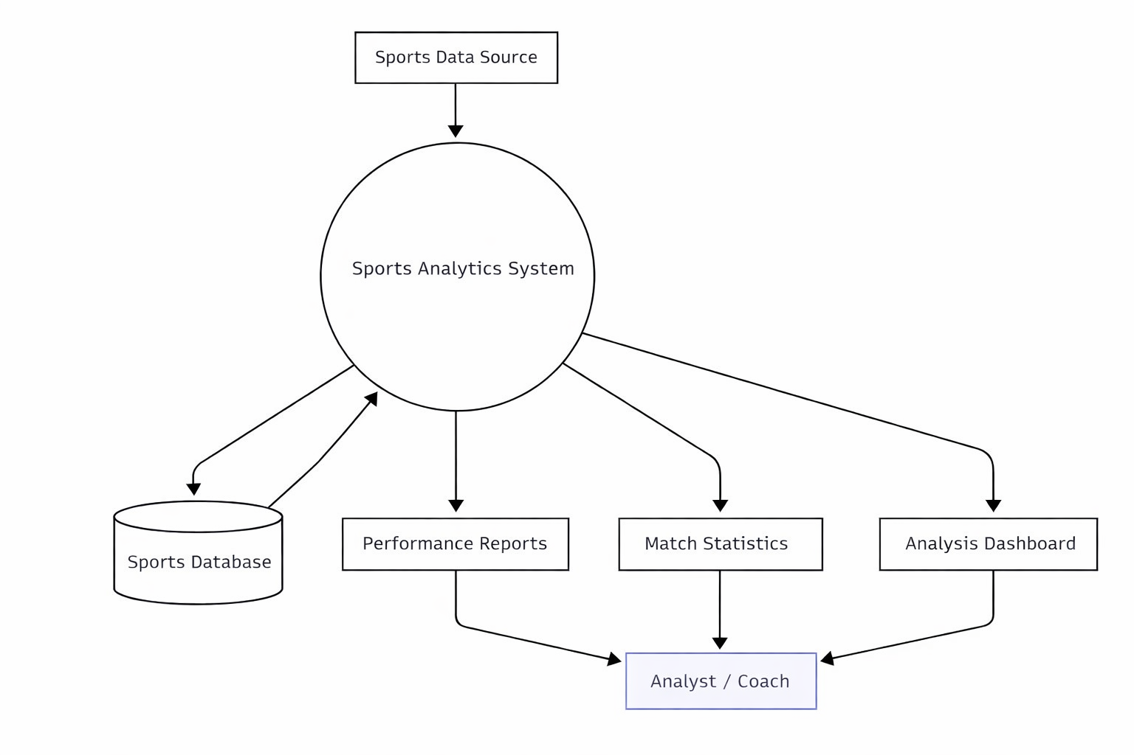
Figure 3.1 (Flow of Data in a Sports Analytics System)

This diagram shows how sports data is transformed into useful insights. Information from sports sources is analyzed by the system, which produces reports, statistics, and dashboards. These outputs are stored in a database and presented to analysts or coaches, helping them track performance and make better decisions during training and matches.

3.4 Feasibility
Technical Feasibility
The Kinetix platform is technically feasible because it can be developed using existing web technologies such as frontend frameworks, backend development tools, and databases. These technologies are widely used and easily available for development. The required software tools and development environments can support the implementation of real-time analytics and user interaction features.
Economic Feasibility
The project is economically feasible since most of the technologies and tools used for development are open-source and freely available. This reduces the cost required for development and maintenance. Therefore, the system can be implemented without significant financial investment.
Operational Feasibility
The system is designed to be simple and user-friendly so that users can easily access sports analytics and prediction features. Analysts can view performance insights while fans can interact with the platform through prediction-based activities. This makes the platform practical and easy to operate for different types of users.

3.5 Requirement Analysis
Requirement analysis identifies the features and functionalities needed for the development of the Kinetix platform. It helps in understanding how the system will operate and what services it will provide to users. The requirements are mainly divided into functional and non-functional requirements.

3.5.1 Functional Requirements
Functional requirements define the main operations that the system must perform to meet user needs and deliver core functionality. The system should allow users to register and log in securely, providing personalized access to the platform. It should offer sports analytics and performance insights based on available match data, enabling analysts to view player performance and match statistics. Additionally, the platform should include a prediction feature that allows users to forecast upcoming match events and maintain a leaderboard or scoring system based on these predictions. The system must efficiently store and manage sports data, user information, and prediction results in the database, while providing visual representations of analytics through charts or dashboards for intuitive and interactive data interpretation.

3.5.2 Non-Functional Requirement
Non-functional requirements define the quality and performance characteristics of the system, ensuring it operates effectively and meets user expectations. The system should provide fast and efficient data processing while remaining user-friendly and easy to navigate. It must ensure data security and protect user privacy, maintaining a safe environment for all users. Additionally, the platform should be scalable to accommodate multiple users simultaneously and remain reliable and stable during usage, supporting consistent performance under varying conditions.

3.6 Methodology
The methodology describes the process followed to develop the Kinetix platform and how the system performs sports analytics and prediction activities. The development process begins with collecting sports-related data such as match statistics, player performance data, and other relevant information. This data is stored in a database where it can be accessed and processed by the system.
After data collection, the system processes the information using analytical methods to evaluate player performance and match statistics. The platform then generates insights and displays them through dashboards and visualizations so that analysts and users can easily understand the results.
The system also includes an interactive prediction feature where users can analyze the current match situation and make predictions about upcoming events during the game. These predictions are compared with the actual match outcomes, and users receive points based on the accuracy of their predictions.
Through this process, the Kinetix platform combines data collection, analysis, visualization, and user interaction to provide a comprehensive sports analytics environment.

CHAPTER 4
DESIGN & IMPLEMENTATION

System Architecture
The Kinetix platform follows a client–server architecture where the user interface interacts with the backend server through web-based APIs. The architecture is designed to support both professional sports analytics and fan interaction features within a unified ecosystem.
The frontend layer is responsible for handling user interactions such as login, registration, viewing match information, and participating in prediction activities. This layer provides an intuitive interface that allows users to easily access platform features. The backend layer processes user requests, manages authentication, performs data processing, and communicates with the database to store or retrieve information.
The database layer stores important information such as user profiles, player performance data, match statistics, and prediction records. This layered architecture allows the system to remain scalable and flexible, enabling additional analytics modules and sports data integration in future phases of development.
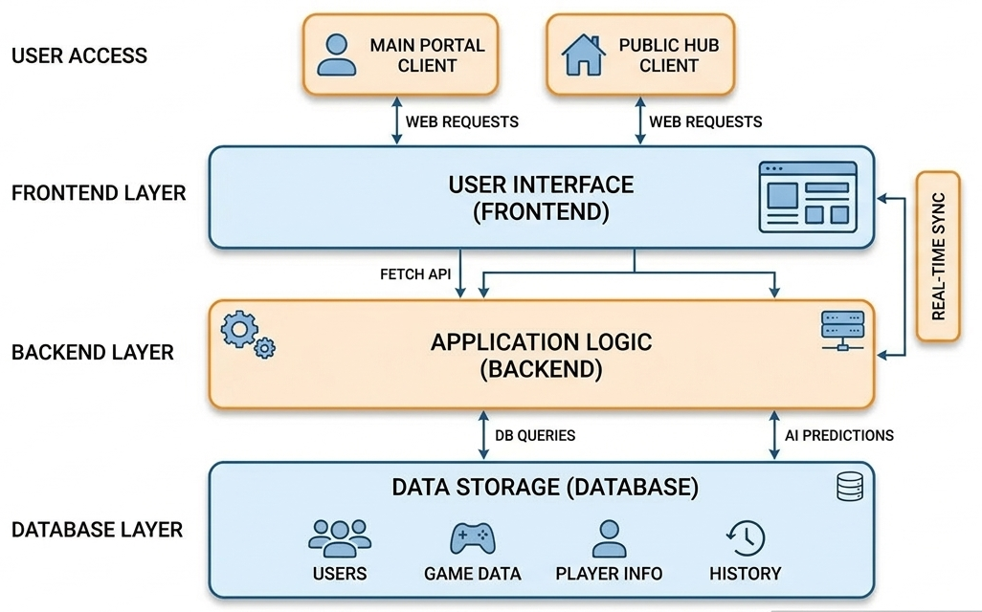

  - System Modules
The Kinetix platform is divided into several functional modules to ensure efficient development, maintainability, and scalability of the system. Each module is responsible for handling a specific part of the platform’s functionality. This modular design allows different components of the system to operate independently while still working together to deliver the overall functionality of the platform.

    - User Management Module
The User Management Module handles all activities related to user registration, authentication, and profile management. This module allows new users to create accounts through a signup process and enables existing users to log into the platform securely. The system verifies user credentials before granting access to platform features.
Additionally, this module manages user information stored in the database and ensures secure access to the system. It forms the foundation for other modules since user authentication is required before accessing analytics or prediction features.
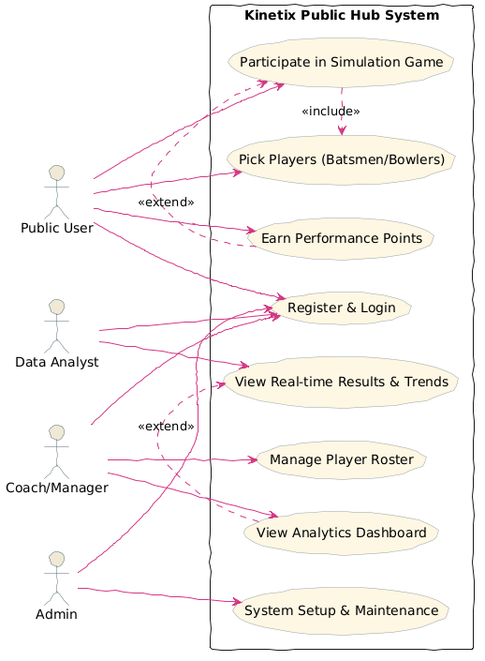
Figure 4.1 Kinetix Public Hub Use Case Diagram
The diagram shows how Public Users, Data Analysts, Coaches/Managers, and Admins interact with the Kinetix Public Hub System. It outlines key functions such as simulation participation, analytics viewing, roster management, and system maintenance, with include and extend relationships clarifying dependencies.

    - Professional Analytics Module
The Professional Analytics Module is designed to provide analytical insights related to sports performance. This module focuses on analyzing player statistics, match data, and performance metrics that can help coaches, analysts, and sports professionals better understand player capabilities and team strategies.
The module aims to present performance-related information through dashboards or statistical summaries. Although the full analytics functionality will be implemented in later stages of development, the module structure has been designed to support advanced data analysis and visualization.
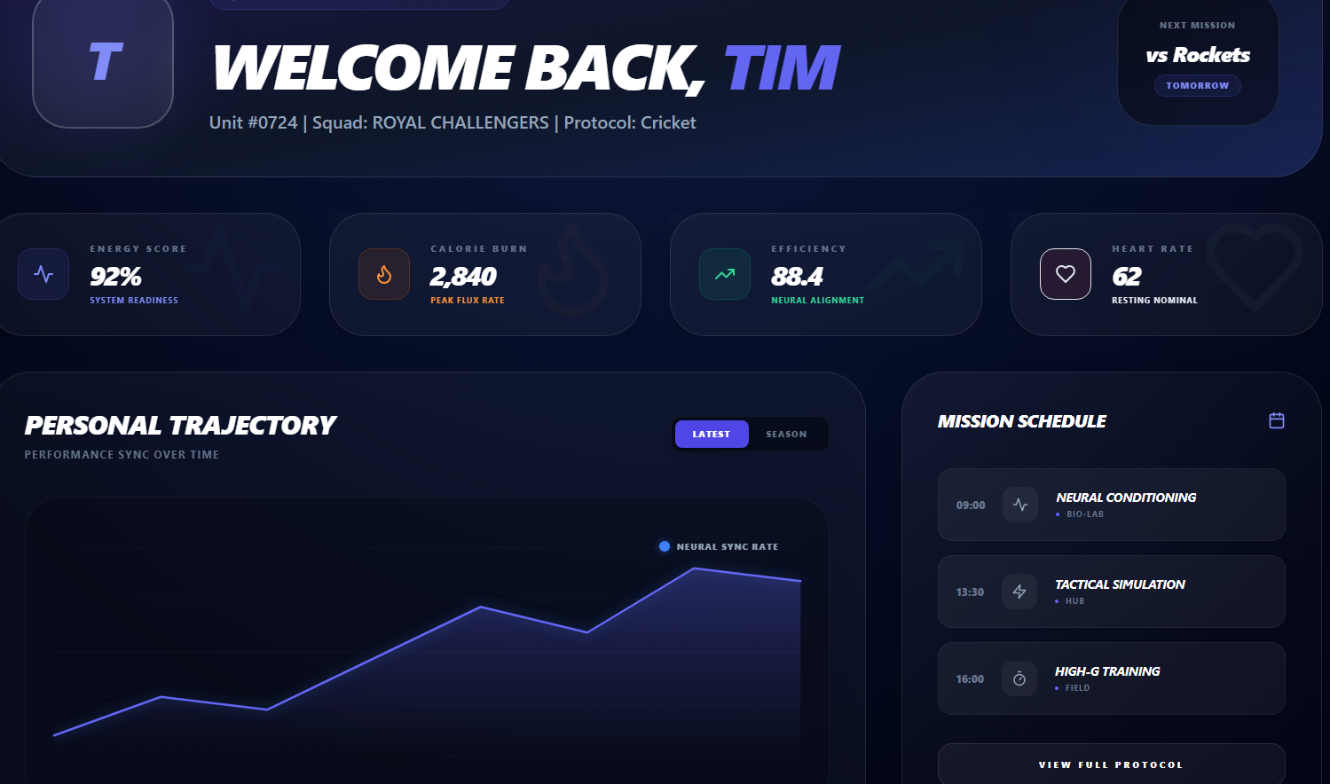
Figure 4.2 Player Performance Dashboard
A futuristic interface of the "ROYAL CHALLENGERS" squad, showing Tim’s energy readiness, calorie burn, efficiency, and heart rate. It tracks neural sync progression, outlines training missions, and highlights the upcoming match against the Rockets. Some advanced components are pending and will be added in future updates.

Public Simulation Hub
The Public Simulation Hub is designed to enhance fan engagement by providing interactive features for sports enthusiasts. One of the key features of this module is the Predict-the-Play system, which allows users to analyze ongoing match situations and predict upcoming events.
Users can participate in prediction activities and earn points for correct predictions through a gamified system. This feature encourages users to engage more deeply with sports events while improving their understanding of game strategies.
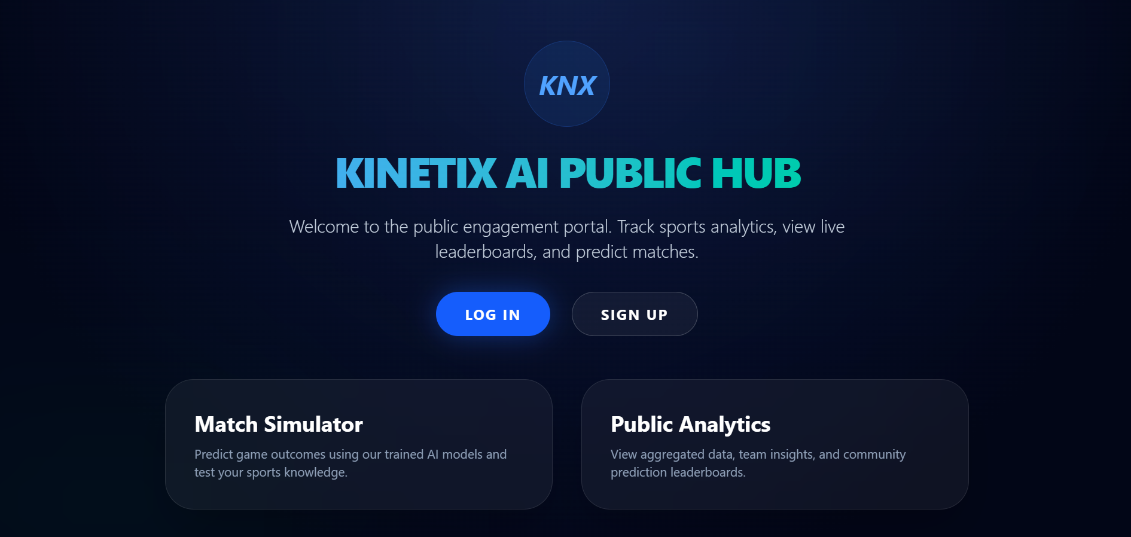
Figure 4.3 Kinetix AI Public Hub Portal
A dark-themed interface showcasing the Kinetix AI Public Hub. It highlights user engagement features such as match simulation for predicting outcomes with AI models and public analytics for viewing aggregated data, team insights, and community leaderboards. Prominent login and signup options emphasize accessibility and participation.

4.2.4 Data Management Module
The Data Management Module is responsible for storing, organizing, and retrieving data used throughout the system. This includes user data, player performance statistics, match information, and prediction records.
The module interacts directly with the database to ensure that all information is properly stored and accessible when required by other system modules. Efficient data management helps maintain system performance and ensures that analytical and prediction features can operate smoothly.
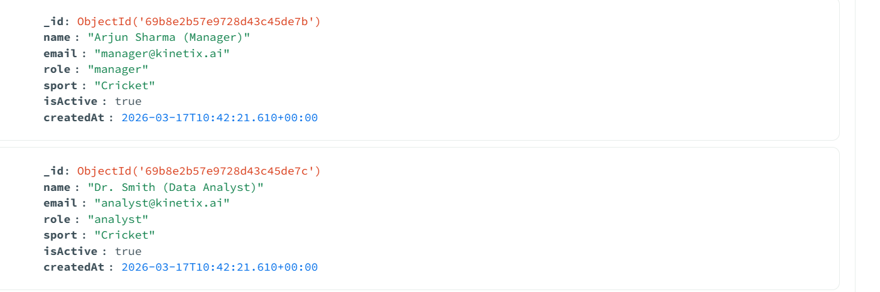
Figure 4.4 Example of User Profile Data Structure in JSON Format

  - Technology Stack
The development of the Kinetix platform utilizes widely used web technologies that support scalable and efficient application development. Layer Technology Frontend HTML, CSS, JavaScript Backend Node.js, Express.js Database MongoDB Development Tools Visual Studio Code.

Table 4.1 Application Tech Stack Overview
Layer | Technology
Frontend | HTML, CSS, JavaScript
Backend | Node.js, Express.js
Database | MongoDB
Development Tools | Visual Studio

This table summarizes the core technologies used across the application’s layers, including frontend (HTML, CSS, JavaScript), backend (Node.js, Express.js), database (MongoDB), and development tools (Visual Studio).

  - Database Design
The database design of the Kinetix platform focuses on storing information related to users, players, matches, and prediction activities. A structured database helps maintain data consistency and enables efficient retrieval of information during system operations.
Some of the main entities in the database include:
    - User Database
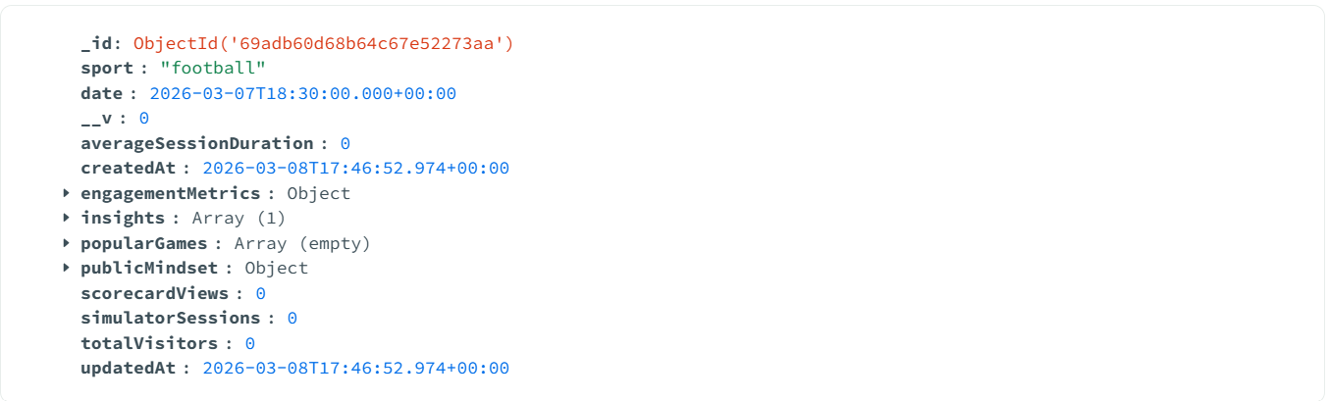
Figure 4.5 User Database Document Structure
This figure shows a sample JSON-like document used to store user engagement data for football analytics. It includes fields such as sport type, event date, session metrics, insights, and timestamps. The structure highlights how user activity and public mindset are tracked, even when no sessions or visitors are recorded.
    - Player Table
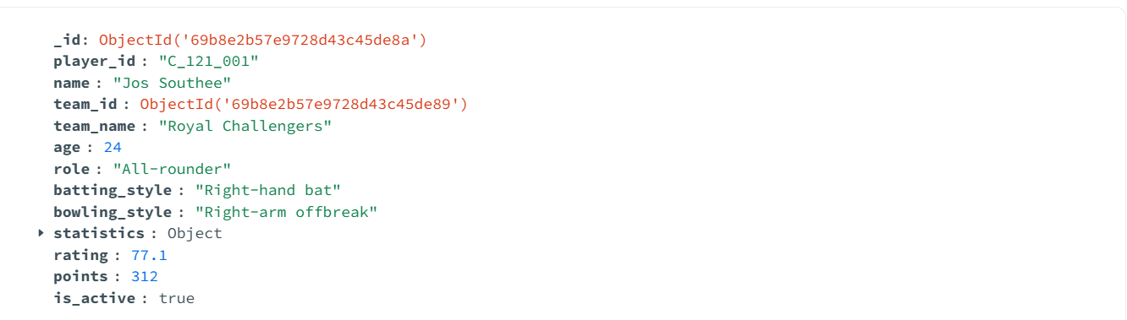
Figure 4.6 Cricket Player Profile Document
This figure shows the structured player data, including personal details, team info, players.

  - User Interface Design
The user interface of the Kinetix platform is designed to be simple, interactive, and user-friendly. The interface allows users to easily navigate through different sections of the platform.
    - Login Page
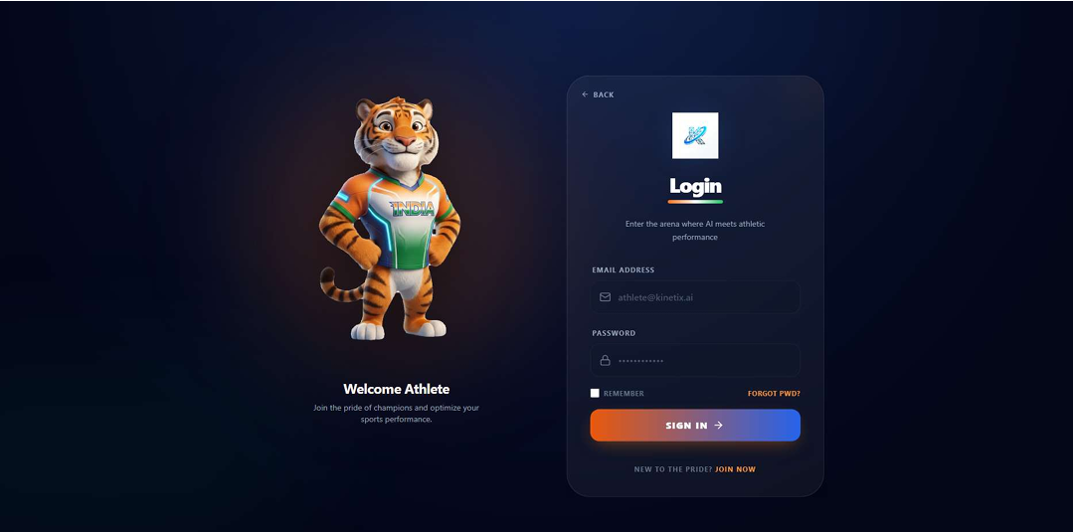
Figure 4.7 Login Interface
This figure displays the login screen of the AI-powered athletic performance platform. It combines a mascot symbolizing sportsmanship with a user-friendly login form, emphasizing the platform’s focus on athletes and performance optimization.

    - Signup Page
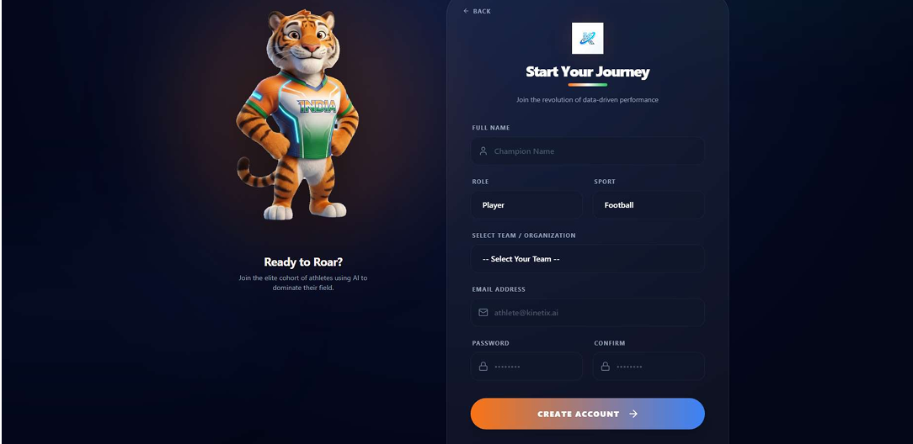
Figure 4.8 Signup Interface
This figure shows the account creation screen of the AI-powered sports platform, featuring a mascot and a registration form for athlete details, team selection, and login credentials.
4.5.3 Dashboard
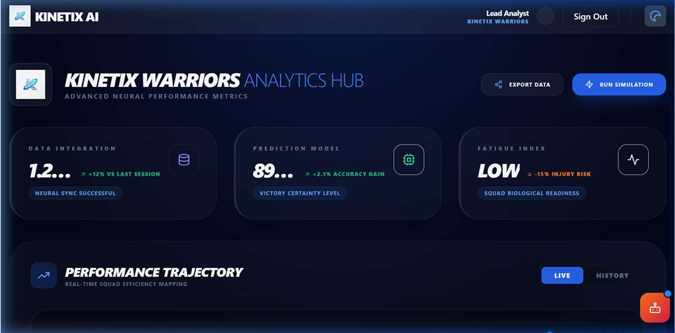
Figure 4.9 Dashboard of Data Analyst
This figure presents the Kinetix Warriors Analytics Hub, showcasing advanced neural performance metrics such as data integration, prediction accuracy, and fatigue index, along with real-time squad efficiency mapping

  - Current Implementation Status
At the current stage of development, approximately 40% of the system has been implemented. The core structure of the project has been established, and several foundational components have been developed.
The implemented features of the project include the establishment of a basic architecture setup, which provides the foundation for system development. A user registration and login system has been integrated to ensure secure access and account management. The initial frontend interface design was created to deliver a user-friendly experience, while a basic database structure was established to organize and store essential information. Finally, seamless integration between the frontend and backend components was achieved, enabling smooth communication and functionality across the application.
These implemented components form the foundation for further development and allow additional modules to be integrated in later phases.

  - Future Implementation Plan
The remaining development phase will focus on completing the analytical and simulation features of the platform. Future work includes implementing advanced sports analytics modules, prediction algorithms, and improved data visualization tools. Additional functionalities such as leaderboard systems, real-time match analytics, and enhanced fan interaction features will also be developed. Continuous testing and performance optimization will be conducted to ensure that the platform operates efficiently. Once implemented, the Kinetix platform will provide a sports analytics ecosystem for professional analysis & fan engagement.

CHAPTER 5
CONCULSION
The Kinetix platform was proposed to address the gap between professional sports analytics systems and fan engagement platforms. Modern sports analysis tools mainly focus on performance evaluation for teams and analysts, while fan-oriented platforms usually provide only basic match information and entertainment features. The objective of this project is to create a unified ecosystem that integrates professional analytics capabilities with interactive fan participation.
During the current stage of development, the system architecture and core design of the platform have been successfully established. The initial implementation includes the user authentication system, basic frontend interface, dashboard structure, and database setup for managing user and player data. These components provide the foundation for further development of the analytics and prediction modules.
Although the project is partially implemented, the proposed architecture demonstrates how data-driven analytics and interactive prediction features can be combined within a single platform. Future development will focus on implementing advanced sports analytics tools, prediction algorithms, real-time match insights, and enhanced user interaction features. Once completed, the Kinetix platform has the potential to support both professional sports performance analysis and deeper fan engagement through an integrated digital ecosystem.

Reference
- Mandot, C., & Chawla, R. (2013, January). Artificial intelligence based integrated cricket coach. In International Conference on Advances in Computing, Communication and Control (pp. 227-236). Berlin, Heidelberg: Springer Berlin Heidelberg.
- Hassan, B., Clough, C., Siddiqi, Y., Ali, R. F., & Arshed, M. A. (2024). PlayerRank: leveraging learning-to-rank AI for player positioning in cricket. IEEE Access.
- Agrawal, Y., & Kandhway, K. (2024). Winner prediction in an ongoing one day international cricket match. Journal of Sports Analytics, 9(4), 305-318.
- Thander, A. (2023). BIOMECHANICS OF THE BOWLING DELIVERY IN CRICKET: A CRITICAL ANALYSIS.
- Obi, O. C., Dawodu, S. O., Onwusinkwue, S., Osasona, F., Atadoga, A., & Daraojimba, A. I. (2024). Data science in sports analytics: A review of performance optimization and fan engagement. World Journal of Advanced Research and Reviews, 21(1), 2663-2670.
- Davis, J., Bransen, L., Devos, L., Jaspers, A., Meert, W., Robberechts, P., ... & Van Roy, M. (2024). Methodology and evaluation in sports analytics: challenges, approaches, and lessons learned. Machine Learning, 113(9), 6977-7010.
- Mohana, J., Bharthvajan, R., Murugesan, M., Omotunde, H., Balaji, D., & Antony, A. S. M. (2024, December). An AI-Driven Approach to Real-Time Sports Analytics and Performance Evaluation. In 2024 International Conference on Innovative Computing, Intelligent Communication and Smart Electrical Systems (ICSES) (pp. 1-7). IEEE.
- Pietraszewski, P., Terbalyan, A., Roczniok, R., Maszczyk, A., Ornowski, K., Manilewska, D., ... & Gołaś, A. (2025). The Role of Artificial Intelligence in Sports Analytics: A Systematic Review and Meta-Analysis of Performance Trends. Applied Sciences, 15(13), 7254.
- Wbaid, S., Ahmatkhonovich, A. M., Pulatova, H., & Afzal, M. (2025, April). Artificial Intelligence-Powered Sports Analytics: Enhancing Performance Through Data Science. In 2025 International Conference on Computational Innovations and Engineering Sustainability (ICCIES) (pp. 1-6). IEEE.
- Pu, Z., Pan, Y., Wang, S., Liu, B., Chen, M., Ma, H., & Cui, Y. (2024). Orientation and decision-making for soccer based on sports analytics and AI: A systematic review. IEEE/CAA Journal of Automatica Sinica, 11(1), 37-57.
- Jain, S. (2025). AI in sports: deep learning models for player performance analysis and injury prediction. International Journal of Research & Technology, 13(1), 11-17.
- Souaifi, M., Dhahbi, W., Jebabli, N., Ceylan, H. İ., Boujabli, M., Muntean, R. I., & Dergaa, I. (2025). Artificial intelligence in sports biomechanics: A scoping review on wearable technology, motion analysis, and injury prevention. Bioengineering, 12(8), 887.
- Pisaniello, A. (2024). The game changer: How artificial intelligence is transforming sports performance and strategy. Geopolitical, Social Security and Freedom Journal, 7(1), 75-84.
- Kim, C., Park, J. H., & Lee, J. Y. (2024). AI-based betting anomaly detection system to ensure fairness in sports and prevent illegal gambling. Scientific Reports, 14(1), 6470.
- Xu, Y., & Peng, Y. (2020, July). Real-Time Possessing Relationship Detection for Sports Analytics. In 2020 39th Chinese Control Conference (CCC) (pp. 7373-7378). IEEE.
- Johansen, H. D., Johansen, D., Kupka, T., Riegler, M. A., & Halvorsen, P. (2020, October). Scalable infrastructure for efficient real-time sports analytics. In Companion publication of the 2020 international conference on multimodal interaction (pp. 230-234).
- Connor, J. D., Sinclair, W. H., Leicht, A. S., & Doma, K. (2019). Analysis of cricket ball type and innings on state level cricket batter’s performance. Frontiers in psychology, 10, 2347.
- Vishwarupe, V., Bedekar, M., Joshi, P. M., Pande, M., Pawar, V., & Shingote, P. (2022). Data analytics in the game of cricket: A novel paradigm. Procedia Computer Science, 204, 937-944.
- Wickramasinghe, I. (2022). Applications of Machine Learning in cricket: A systematic review. Machine Learning with Applications, 10, 100435.
- Mahajan, M., Kulkarni, S., Kulkarni, M., Sabale, A., & Thakar, A. (2024). Deep learning in cricket: A comprehensive survey of shot detection and performance analysis. International Research Journal on Advanced Engineering Hub (IRJAEH), 2(06), 1748-1754
- Zhou, D., Keogh, J. W., Ma, Y., Tong, R. K., Khan, A. R., & Jennings, N. R. (2025). Artificial intelligence in sport: A narrative review of applications, challenges and future trends. Journal of Sports Sciences, 1-16.
Appendix
